The Kansas Department of Health and Environment (KDHE) and [Allen County Rural Water District #8] is focused on protecting the health of every household in our community. This notice contains important information about your drinking water. Please share this information with anyone who drinks and/or cooks using water at this address.

You’re being notified because your water system has determined that a portion of or the entire water pipe that connects your [home, building, or other structure] to the water main is made from one of the following:

[ ] Lead
[ ] Galvanized Material
[ ] Unknown Material
Lead
People living in homes with a lead service line may have an increased risk of exposure to lead in their drinking water.
Galvanized Material
Galvanized service lines that have absorbed lead can contribute to lead in drinking water. People living in homes with a galvanized service line downstream of lead may have increased risk of exposure to lead in their drinking water.
Unknown Material
Because your service line material is unknown, there is the potential that some or all of the service line could be made of lead or galvanized pipe previously connected to lead. People living in homes with lead or galvanized pipe previously connected to a lead service line have an increased risk of exposure to lead from their drinking water.
If you need help identifying your plumbing, we encourage you to contact your water system.

HEALTH EFFECTS OF LEAD

Exposure to lead in drinking water can cause serious health effects in all age groups. Infants and children can have decreases in IQ and attention span. Lead exposure can lead to new learning and behavior problems or worsen existing learning and behavior problems. The children of women who are exposed to lead before or during pregnancy can have an increased risk of these negative health effects. Adults can have increased risks of heart disease, high blood pressure, kidney, or nervous system problems.

POSSIBLE SOURCES OF LEAD IN DRINKING WATER

When water is in contact with pipes, and plumbing containing lead, the lead may enter drinking water. Homes built in Kansas before the 1988 lead ban are more likely to have lead pipes or lead solder.

Water lines made of lead, copper pipe with lead solder, galvanized lines that may have ever had lead upstream could have lead attached, brass faucets, fittings, and valves, including those advertised as “lead-free,” may contribute lead in drinking water. Lead is not normally found in Kansas, source water supplies from lakes, rivers, streams or groundwater.

STEPS YOU CAN TAKE
TO REDUCE YOUR EXPOSURE TO LEAD IN YOUR WATER
- Use of water filter

Using a filter can reduce lead in drinking water. If you use a filter, it should be certified to remove lead. Read any directions provided with the filter to learn how to properly install, maintain, and use your cartridge and when to replace it. Using the cartridge after it has expired can make it less effective at removing lead. Do not run hot water through the filter that you use for drinking or cooking.

- Clean your aerator

Regularly clean your faucet’s screen. Sediment debris, and lead particles can collect in your aerator. If lead particles are caught in the aerator, lead can get into your water. Turn on full flow to let water run after cleaning. After replacing the clean aerator turn on full flow to let water run to flush loose particles after cleaning before drinking.

- Use cold water

Do not use hot water from the tap for drinking, cooking, or making baby formulas as lead dissolves more easily into hot water. Boiling water does not remove lead from water.

- Run Your Water

If your water has been sitting in the pipes for more than 18 hours, the more lead it may contain. Before drinking, let the water run for at least 30 seconds or until the temperature changes.


Notification of Known or Potential Service Line Containing Lead
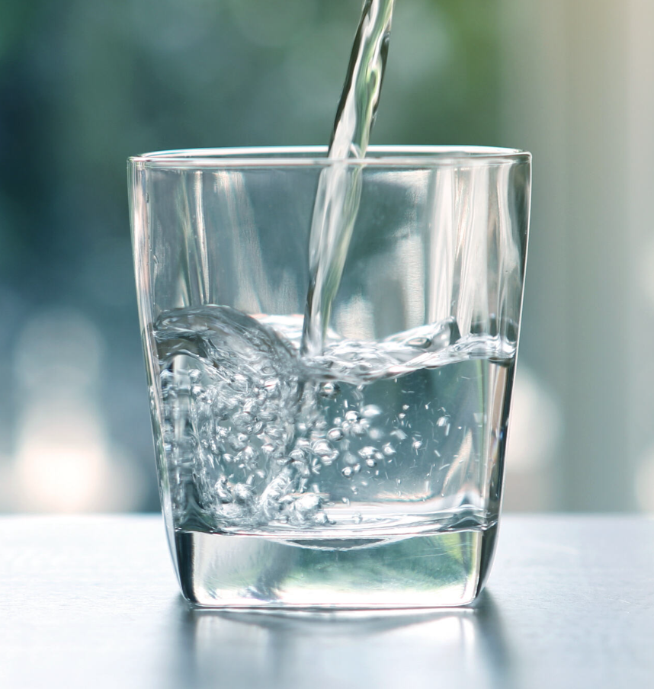
5. If you’re concerned about construction disturbing your service lines

Contact your water system to find out about any construction or maintenance work that could disturb your service lines. Construction may cause more lead to be released from a lead service line or galvanized service line if lead is present.

6. If you want your water tested

Contact your water system to learn about your options for having your water tested for lead.

7. Get your child tested to determine lead levels in their blood

A family doctor, pediatrician, or your County Health Department can perform a childhood blood lead level test and provide information about the health effects of lead. KDHE can also provide information about how you can have your child’s blood tested for lead.

8. Replacing lead service lines or galvanized requiring replacement service lines.

If you replace your service lines, make sure to use filters for 6 months after service line replacement. For questions on filters, contact your water system.

For information about potential financial solutions to assist property owners with replacement of lead service lines, please contact your water system.

For more information on reducing lead exposure from your drinking water and the health effects of lead, visit EPA’s website at http://www.epa.gov/lead

or visit

KDHE’s website at www.kdheks.gov/water

POSSIBLE OTHER SOURCES OF LEAD EXPOSURE

Lead is a common metal found in the environment. Drinking water is only one possible source of lead exposure. The main sources of lead exposure are lead-based paint and lead-contaminated dust or soil, and some plumbing materials. In addition, lead can be found in certain types of pottery, pewter, brass fixtures, food, and cosmetics. Other sources include exposure in the workplace and exposure from certain hobbies (lead can be carried on clothing or shoes). Lead is found in some toys, some playground equipment, and some children's metal jewelry.

